JavaScript – Part 2 Intermediate Exam – 16 May 2013 Variant 2

Exam terms – Read carefully!
During the exam you are allowed to use any teaching materials, lectures, books, existing source code, and other paper or Internet resources. Direct or indirect communication with anyone in the class or outside the room is absolutely forbidden. This includes but does not limit the restrictions to: technical conversations with other students, mobile phones usage, chat software, email, forum posts, etc.
All students who ignore our rules and cheat during the exam will be disqualified from all our courses.
You have exactly 6 hours to solve all given problems. Good luck!
No external JavaScript libraries can be used (like jQuery, KendoUI, etc…).
The sample UI and code snippets are not obligatory and are not necessary to follow.

Implement an ImageGallery control

Task Overview
Implement an ImageGallery control that has the following characteristics:
- The ImageGallery can contain a set of images (directly) and a set of albums
- Images have title and image source (static or relative path to their location)
- Albums have title, can contain a set of images and can have nested albums
- Albums can be expanded and collapsed
- The images are always visualized at the top of their album
- The albums are always visualized after the images, if any

General Requirements. Overall implementation of the tasks
- Escaping of the strings
  - <br /> should be visualized in the ImageGallery as "<br />" and not as new line
- Using object-oriented principles
  - Creating function constructors for ImageGallery, Image and Album
  - Use module or prototype pattern
- Cross-browser implementation
  - The ImageGallery should work on Chrome 26, Firefox 20, Opera 12 and IE 8, 9 and 10
Up to 20 points

Task 1
Implement adding images and albums dynamically
- Adding an image with a title and image source
- Adding album with a title
- Adding images to an album
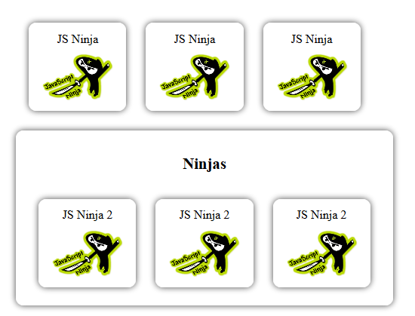
var gallery = controls.getImageGallery("#image-gallery-holder");
gallery.addImage("JS Ninja", "images/js-ninja.png");
gallery.addImage("JS Ninja", "images/js-ninja.png");
gallery.addImage("JS Ninja", "images/js-ninja.png");
var ninjasAlbum = gallery.addAlbum("Ninjas");
ninjasAlbum.addImage("JS Ninja 2", "images/js-ninja.png");
ninjasAlbum.addImage("JS Ninja 2", "images/js-ninja.png");
ninjasAlbum.addImage("JS Ninja 2", "images/js-ninja.png");
Up to 9 points

Task 2
Implement adding of nested Albums inside the ImageGallery and inside another Album
- The ImageGallery and every album can contain zero or more nested albums
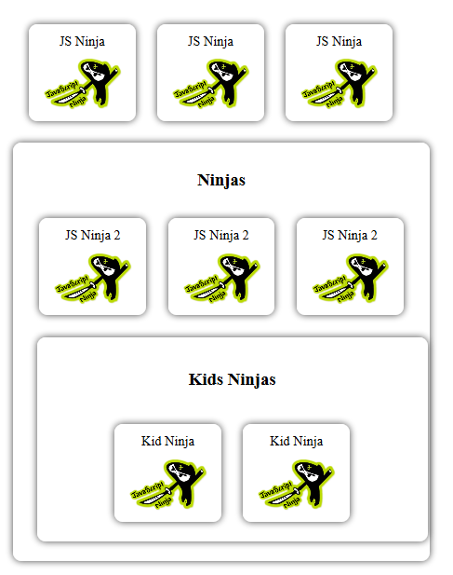
var ninjasAlbum = gallery.addAlbum("Ninjas");
gallery.addImage("JS Ninja", "images/javascript-ninja.png");
gallery.addImage("JS Ninja", "images/javascript-ninja.png");
gallery.addImage("JS Ninja", "images/javascript-ninja.png");
ninjasAlbum.addImage("JS Ninja 2", "images/javascript-ninja.png");
ninjasAlbum.addImage("JS Ninja 2", "images/javascript-ninja.png");
ninjasAlbum.addImage("JS Ninja 2", "images/javascript-ninja.png");
var kidsAlbum = ninjasAlbum.addAlbum("Kids Ninjas");
kidsAlbum.addImage("Kid Ninja", "images/javascript-ninja.png");
kidsAlbum.addImage("Kid Ninja", "images/javascript-ninja.png");
Up to 12 points
Task 3. Add expand/collapse behavior
- When an collapsed album's title is clicked, it content is expanded (the images and the albums inside it)
- When an expanded album's title is clicked, it content is collapsed (the images and the albums inside it)
- If no images or albums, the click should do nothing
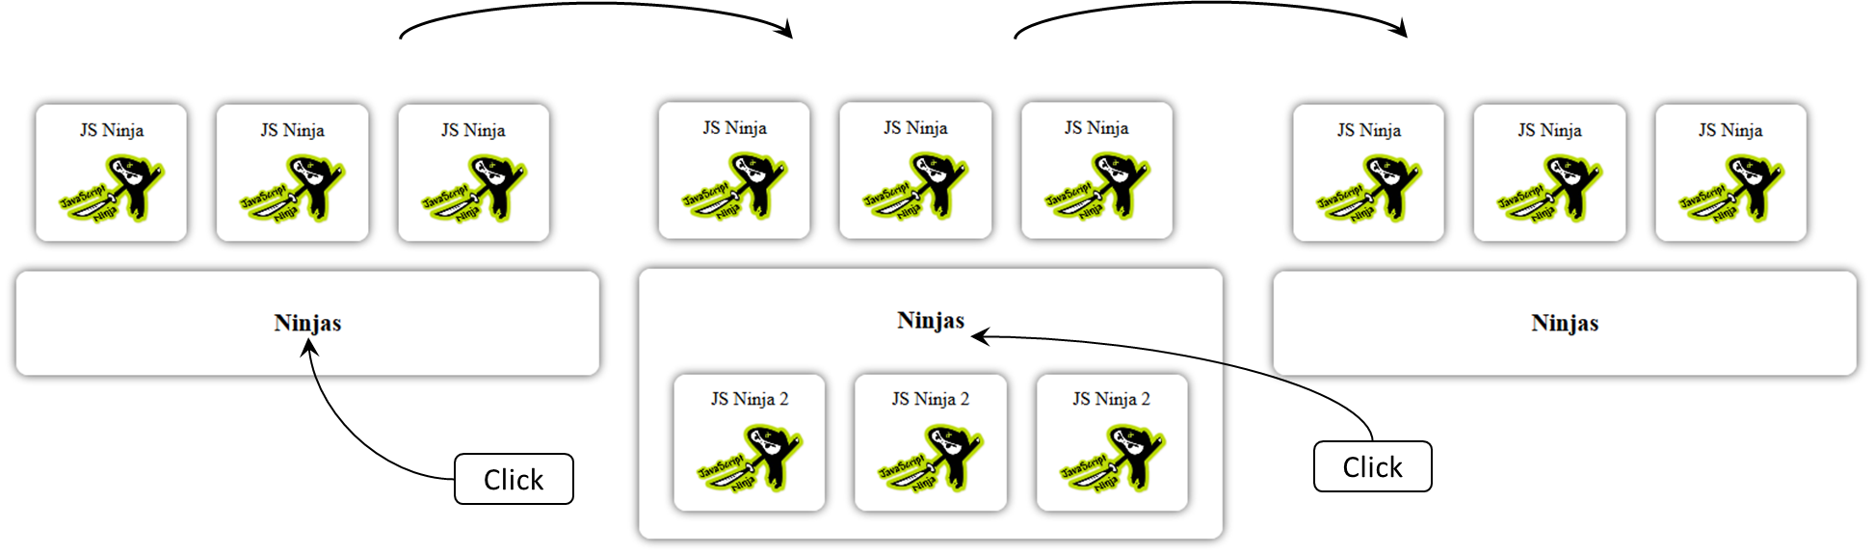
Up to 11 points

Task 4
Create a repository in localStorage, to save and load data for an ImageGallery:
- Keep in localStorage a set of images and albums
- Albums have title, set of images and set of albums
- Images have title and image source (a string representing the location of the image)
- Implement an imageGalleryRepository object that provides functionality for saving and loading ImageGallery data from localStorage
var imageGalleryData = [/* image gallery data */]
imageGalleryRepository.save ("ninjas-gallery", imageGalleryData);
var galleryData = imageGalleryRepository.load("ninjas-gallery");
Up to 5 points

Task 5
Implement functionality to get data from an ImageGallery and save it into the imageGalleryRepository
- Get the titles of all images and albums, and put them in objects
var ninjasImageGallery = controls.getImageGallery("#image-gallery-holder");
//add images and albums to an ImageGallery
var imageGalleryData = ninjasImageGallery.getImageGalleryData();
imageGalleryRepository.save ("ninjas-gallery", imageGalleryData);
Up to 15 points

Task 6
Implement functionality to build an ImageGallery using data from an imageGallery repository:
- The new ImageGallery should look like the original
var imageGalleryData = imageGalleryRepository.load("ninjas-gallery");
var ninjasGallery = controls.buildImageGallery("#ninjas-gallery", imageGalleryData);
Up to 15 points

Task 7
Implement functionality to show the enlarged version of the selected image
- When an image is clicked, it should be visualized outside the ImageGallery, with size 200% of the original
  - Both the selected and the enlarged images should have the same image source
- At most one enlarged image should be present at all times
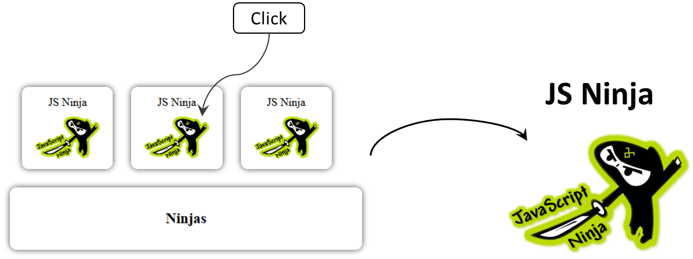
Up to 5 points

Task 8
Implement functionality for sorting albums by title
- The ImageGallery and each album should contain a button for sorting
  - When the button is clicked, all albums directly inside this album/ImageGallery are sorted alphabetically by title ascending
  - If the button is clicked twice, the albums are sorted descending

Up to 10 points

Files to Submit
You should submit an archive, containing all of your work - .js, .css, .html files, etc.
It is very important to provide a sample.html file which illustrates the usage of your code:
- For each of the tasks provide sample code in the following format:
<!--Task number: …-->
…code…
  - There is no need to provide sample code for tasks which do not require writing code for testing (e.g. collapse and expand – they can be tested directly from the UI)

